**RIBCAGE SOLUTIONS, INC.**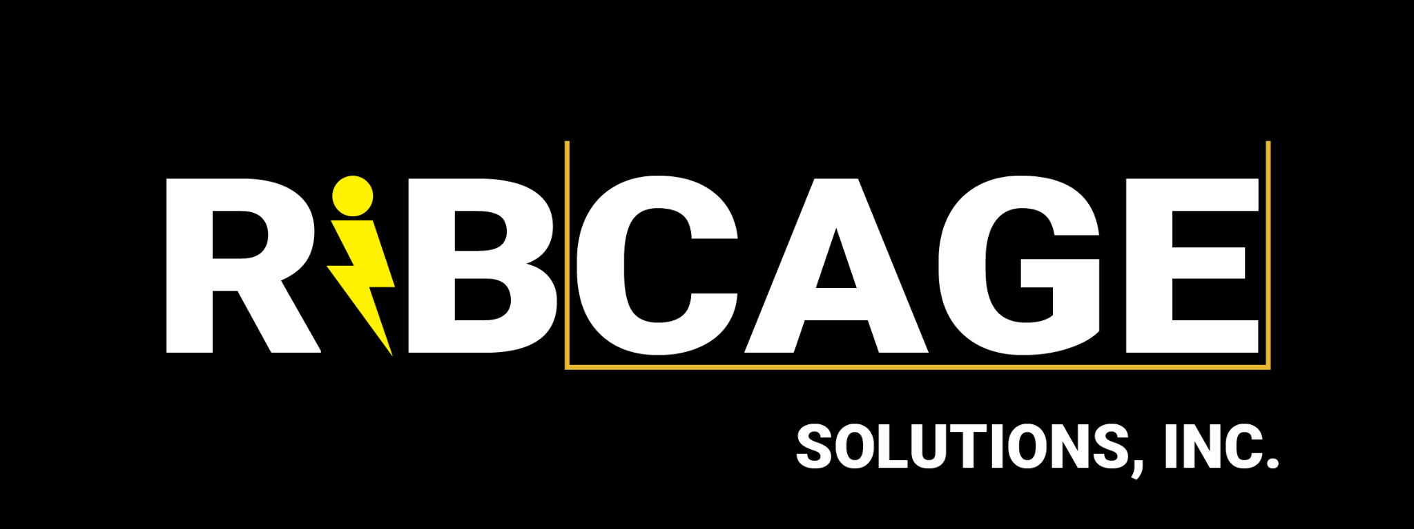

§1 - Georgia Market Overview - Market Research

1. TAM+SAM+SOM:

~280 total productions in Georgia/year (2022 data ~30 features, ~250 TV shows)

~1/10 stages are warehouse stages

~28 productions in GA/yr shooting on warehouse stages (TAM)

~⅕ Locations need external power (conservative, no way to estimate)

~56 productions in GA/yr shooting on locations without enough power

= ~84 productions in GA/yr that need lightning protection

= 84 productions * $30k RoS

= $2.52m

Our TAM is $2.5MM in GA.

1. Our SAM is a year one goal of 20 RoS rentals in GA (20x $30k=$600k) through establishing vendor relationships with the major studios and streaming service production arms, direct outreach to UPMs, word-of-mouth via networking and MBS.
2. Serviceable Obtainable Market (SOM) Roadmap
   1. Depends on how many productions we can reach out to.
      1. Difficult to reach UPMs
         1. Need connections to UPMs, networks. We have a contact list and a lead list. We are building this out, looking for an acceptable affiliate model for the industry.
   2. We expect to reach every major studio within our first year of operation, thereby putting all studio productions within our SAM reach. This does not, however, guarantee that each production is in our SOM at the end of the year because the decision to rent an ARCANGEL kit is initially up to the UPM and decided on a per-shoot-week-per-production basis. Later on, we expect studios themselves to expand their budgeting policies in production manuals based on Ribcage’s value-add to crew safety and lightning related exposure.

§2 - Supply Chain Management

1. We have a profit sharing agreement with MBS. The agreement is that we share 20% of rental profits and they do all the fulfillment, L&D, and billing. They also help us obtain clients via their rental agents. Under the agreement, we have a credit line for inventory (for $25k/run at a time) that allows us to whip up 25 units whenever we need. We split 80/20 in our favor when we are not in debt, but 30/70 in MBS favor when we are. Whenever possible, MBS also provides the packaging. In our first manufacturing run, they gave us $12,000 worth of cases for the kits.
2. We were able to significantly reduce the supply chain costs via our partnerships. Our current cost per kit is ~$800 in parts and $600 in packaging per kit for ~$1400 total. Our current supplier is ECLE.
3. Runs of 25 units are the most cost-effective for us. We currently have 25 units in inventory bought via the MBS credit line. We owe them $25k to be paid via profit sharing to them, at their 70% take rate (while we are indebted).

§3 - Startup Roadmap

Costs

Utility Patent is pending, already paid completely, but may cost additional $3,000-$10,000 in legal fees to push through if it gets rejected.

Operations in GA

* + 1. Housing @ <$3,000/mo
       1. Including garage storage space
       2. Small work space/2 people
       3. Small living space/2 people
       4. Utilities

Outbound Shipping

* + 1. Handled by MBS
       1. MBS Equipment Co. handles all fulfillment to shows and they have warehouses in GA, NM, LI which are the main states we intend to serve.

Return Shipping

* + 1. Handled by Productions
       1. Each production will disassemble their rentals, pack them into the original bins, and return the bins to MBS. They will then be inspected by MBS for losses and damages.

Auxiliary Strategic Growth: Additional Revenue Stream Opportunity:

* + 1. All of the grounding conductors need to be encased in non-conductive protective shielding. This is usually achieved on productions via Yellowjacket cable protectors. 1-Channel Yellowjackets are about $45/3ft and grounding must take place a minimum of 20 ft away from the ARCANGEL. Two conductors means 40 ft total, which is 14 yellowjackets/ARCANGEL, giving us **$1260/kit in yellowjacket costs up front**. Vendors rent 5-Channel yellowjackets (which cost $300-400) @ $15/day, so it would be in our strategic interest to rent them out ourselves at a comparable cost of between $2-5/day/ea. Setting this up could be a play with MBS.

§4 - Risks

Risks

1. Fewer productions have a use for shooting inside during lightning storms than expected
   * 1. This is possible but, as an added safety measure, it’s also possible that each studio would calculate their exposure to lightning shutdowns and require all productions to shield their generators and HVAC units regardless of weather forecasts. This is not unreasonable because, for example, productions pay incredible amounts in life insurance for stars to cover liability to the entire loss of the project if one of the stars dies in a plane crash, specifically; there is also a pending lawsuit against Warner Brothers regarding lightning safety. Chance of a plane crash is 1/11,000,000 and chance of being struck by lightning is 1/300,000, so exposure to a plane crash is minimal compared to exposure to lightning shutdowns yet tens of thousands are spent on every show to fly the star in certain ways so the insurance policy stays in place.Direct lightning strikes or side flashes (lightning arcs from object to object) are statistically much more likely to kill a star than a plane crash, so it’s in the interest of the production to do what they can to protect from this possibility.
   1. Drowning from debt due to delays
      1. The strike significantly affected us. We were poised to continue momentum from the Amazon rental and launch Ribcage in Georgia this in 2023. Instead, the industry was shut down the entirety of lightning season (May-Oct). This poses a serious danger to Ribcage, because we intended to rely on the revenue from the summer to continue operations. We began the strike with $15,000 cash in hand, and ended it with -$40,000k. Until we return to work, this is ballooning. When work returns, it won’t be lightning season, so both co-founders will need to return to work. This will compound negatively with the capability to do marketing and networking, which needs to be continually nurtured in every possible way from now until next lightning season to ensure the correct traction for a successful launch in GA.

§5 - Ask

We are asking $250k for 20% at a $2.5m valuation. We believe we need this $250k for 1) getting out of the red from the strike 2) runway to market for 2024 to ensure a launch that establishes us firmly as the industry leader for lightning protection by May:

($100,000 debt removal)

+

($50,000*2 = living expenses per year/founder)

+

($50,000 = attending trade shows + campaigning to UPMs directly)

= optimal start-up investment to cover GA launch by next lightning season (May-August)

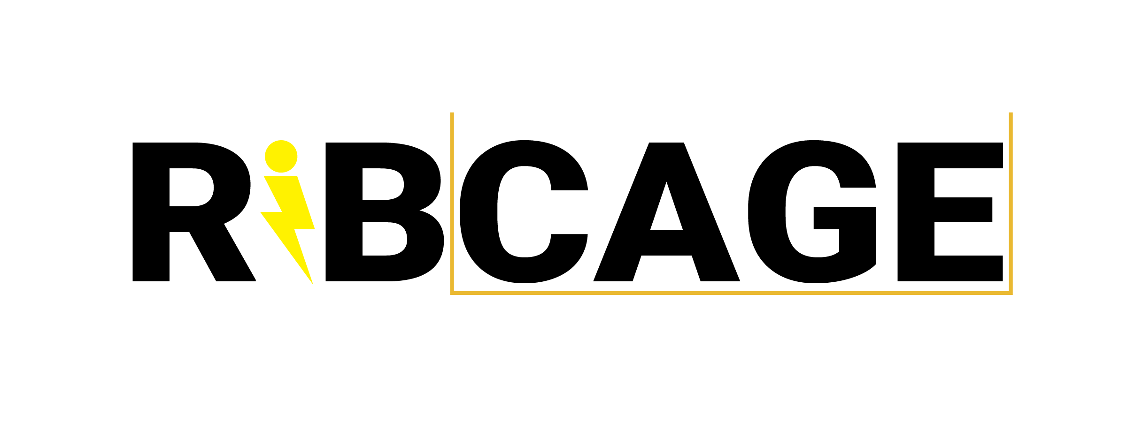

Contact us

[info@ribcagesolutions.com](mailto:info@ribcagesolutions.com)

We look forward to hearing from you!

RIBCAGE SOLUTIONS INC. in no way provides or lays claim to any provision of any mode of insurance against lightning related events and assumes no liability for related damages, regardless of “protection” status, to items or people inside a RIBCAGE. We only claim that RIBCAGEs adequately ground generators for lightning strikes and that a lightning strike *should* be grounded by our system, although it is still possible for a lightning strike to overpower our lightning protection system or for other environmental factors to interfere with the effectiveness of lightning protection systems. RIBCAGEs are sold solely as a piece of equipment to satisfy conditions for generator related workplace safety when in a shelter during a lightning storm. Use at your own risk.